Handedness and Twist
Authors: Shuchismita Dutta, Rutgers University, NJ

ASBMB Learning Objectives
(https://www.asbmb.org/education/core-concept-teaching-strategies/foundational-concepts/structure-function)
1. Biological macromolecules are large and complex
- Students should be able to describe the basic units of the macromolecules and the types of linkages between them (Introductory).
2. Structure is determined by several factors
- Students should be able to discuss the chemical and physical relationships between composition and structure of macromolecules (Introductory).

Introduction
Amino acids are chiral molecules, so secondary structural elements in polymers of amino acids (proteins) also have specific handedness. The two main secondary structural elements discussed here are ɑ-helices and ꞵ-sheets.

Learn more about these secondary structural elements by reading the learning materials “Exploring Levels of Protein Structures in the PDB” in the Box of Lessons, and also “Hierarchical Structure of Proteins”.

Here we examine the handedness of ɑ-helices and twist of ꞵ-sheets in PDB structures.

ɑ-helices
Most ɑ-helices found in protein structures in the Protein Data Bank (PDB) are right-handed. However, a few proteins in the PDB also have left-handed helices.

How can you recognize if a helix is right-handed or left-handed?
Follow the direction of rotation of the protein backbone from the N- to C-terminal end in this region to:
- Match the curling of your right-hand fingers (to indicate a right-handed helix, Figure 1A) or your left hand (to indicate a left-handed helix, Figure 2A). In either case, the thumb should be pointing towards the C-terminus (end) of the helix.
- Follow the railing of a spiral staircase - if the railing is towards your right hand when climbing up the stairs anticlockwise (Figure 1B) it is right-handed, while if the railing is towards your left hand when climbing up the stairs clockwise (Figure 2B) it is left-handed.
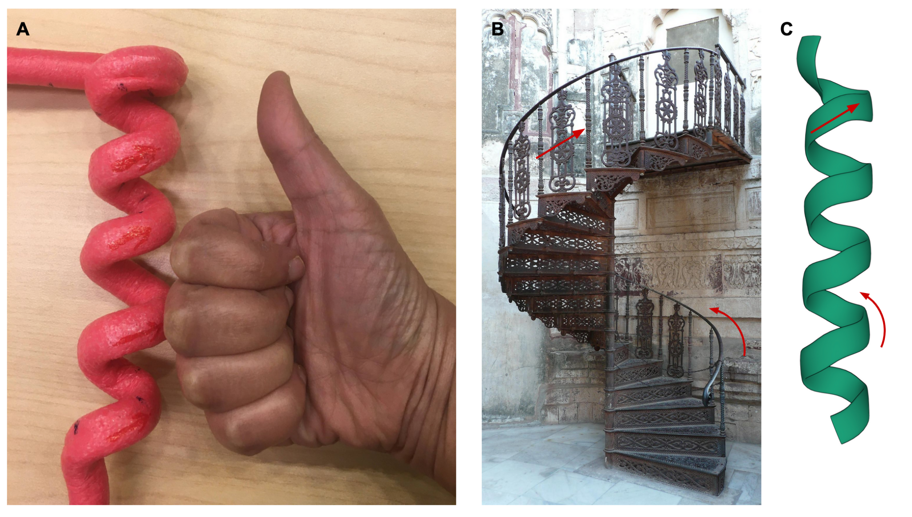
Figure 1: Identifying right-handed ɑ-helices. A. 3D model of a right-handed helix alongside a right hand indicating finger curling and thumb; B. A spiral staircase with the railing on the right-hand side (when climbing up the stairs); C. part of an alpha helix from PDB ID 4hhb (amino acids A53-A71). Staircase images from Pixabay.

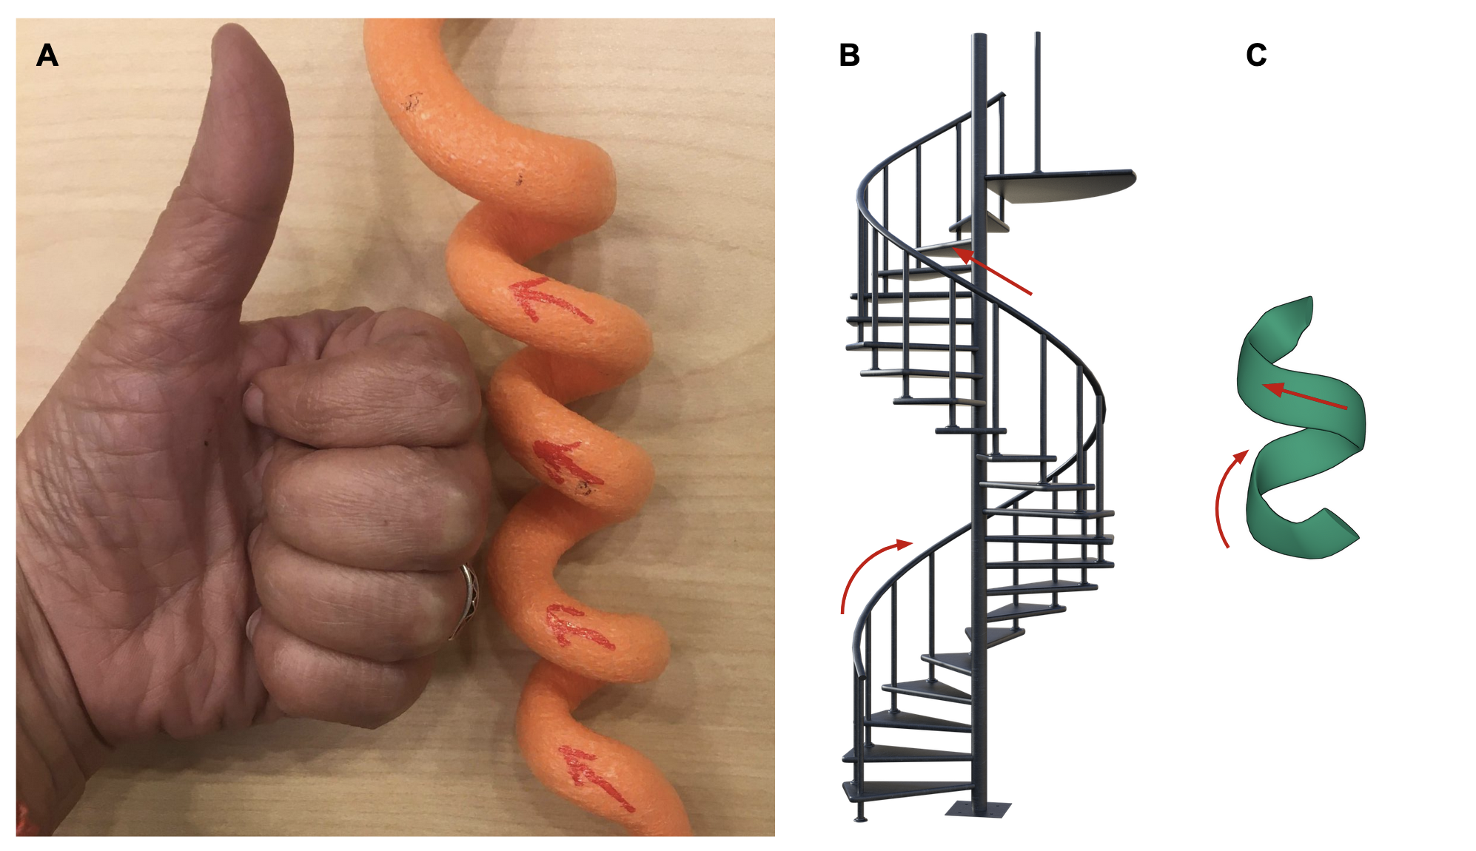
Figure 2: Identifying left-handed ɑ-helices. A. 3D model of a left-handed helix alongside a left hand indicating finger curling and thumb; B. A spiral staircase with the railing on the left-hand side (when climbing up the stairs); C. part of an alpha helix from PDB ID 1bd0 (amino acids K39-G44). Staircase images from Pixabay.

ꞵ-sheets
Each ꞵ-strand seen in PDB structures has a slight right-handed twist. When two or more strands form a ꞵ-sheet, the sheet has a left-handed twist.

How can you recognize if the twists in the ꞵ-strand is right-handed or left-handed?
View a single ꞵ-strand in a structure (Figure 3A). The N-terminus of the strand is at the base of the arrow (on the left of the page), while the C-terminus is at the tip of the arrow (on the right). Imagine that the ꞵ-strands is represented by a strip of paper with an arrow drawn on it (Figure 3B) as viewed from the top of (see eye position in Figure 3A).
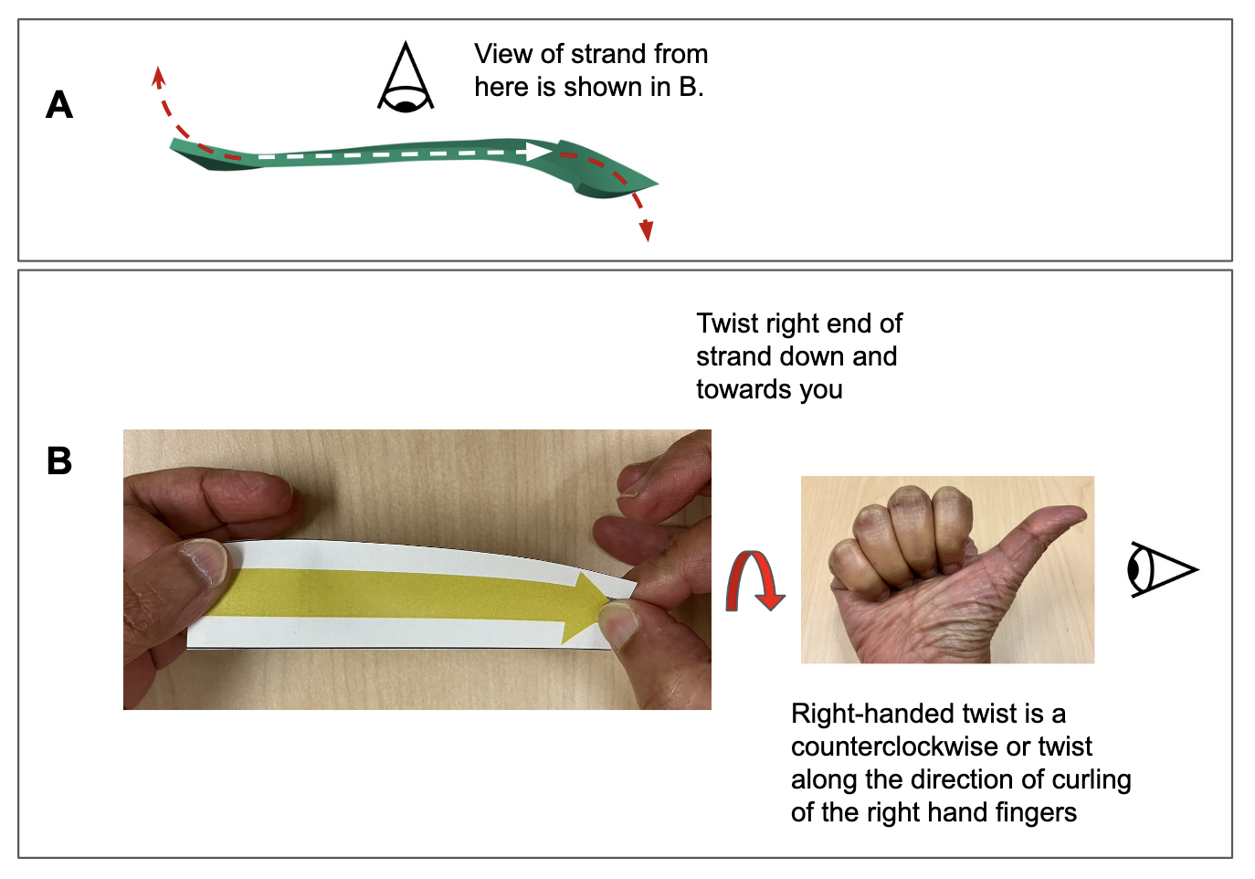
Figure 3: Identifying handedness of a ꞵ-strand. A. A ꞵ-strand from PDB ID 3eye (amino acids G60-F64) showing the twist in the strand. B. A strip of paper with an arrowhead that represents a ꞵ-strand is held with two hands. Twisting the right end of the arrowhead counterclockwise (see red arrow) like the curling of the fingers in a right-handed fist.
Follow the direction of the ꞵ-strand’s peptide backbone (shown in Figure 3A) to note that the base and tip of the strand are twisted with respect to the rest of the strand. Use the paper model (shown in Figure 3B) to determine the direction of the twist.
- Hold the right end of the paper strip in your right hand and the left end in your left hand.
- Twist the right end of the strip towards yourself - this results in a counterclockwise rotation of this end as viewed from the right end of the strand. (Note that the left end of the strand is simultaneously twisted away from you to facilitate this twist)
- Let’s focus on the counterclockwise rotation at the right end of the strip - note that it mimics the curling of the fingers in a right-handed fist (as viewed from the thumb, shown in Figure 3B), hence this is called a right-handed twist.
- The same right-handed twist is seen whether you hold the paper model of the ꞵ-strand with the arrowhead or the base in your right hand.

How can you recognize if the twist in the ꞵ-sheet is right-handed or left-handed?
ꞵ-sheets have a left-handed twist. In parallel sheets all the strands have their N- and C-termini aligned in the same orientation (see arrowheads of all strands on the right in Figure 4A), while in antiparallel sheets they alternate (see arrowheads of alternate strands on the right of Figure 4C)
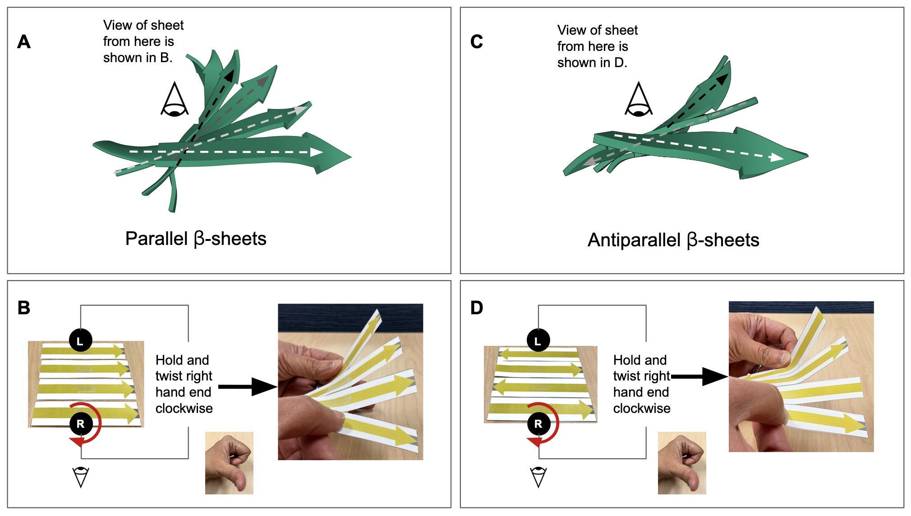
Figure 4: Identifying handedness of ꞵ-sheets. The arrowheads represent the C-terminal ends of the strands. The N- to C-terminal direction of the strands is marked with dashed arrows. The strand closest to you is marked with the white arrow and each of the strands next to it are marked with similar arrows but with progressively darker shades (e.g., grey, black). A. A parallel ꞵ-sheet from the PDB ID 3eye.; B. Representation of a parallel ꞵ-sheet as a paper model showing 4 adjacent ꞵ-strands with the same N- to C-terminal orientation. The sheet is held across the center at the places marked R and L and twisted in a clockwise manner (as the fingers curl in your left-hand fist) to give the sheet a left-handed twist; C. An antiparallel ꞵ-sheet from the PDB ID 3tbo. D. Representation of an antiparallel ꞵ-sheet as a paper model showing 4 adjacent ꞵ-strands with alternating N- to C-terminal orientation. The sheet is held across the center at the places marked R and L and twisted in a clockwise manner (as the fingers curl in your left-hand fist) to give the sheet a left-handed twist;

View the structures of a parallel and an antiparallel ꞵ-sheet (Figures 4A and 4C) from the top of the sheet (as shown by the position of the eye in these figures). Paper models representing these sheets are shown in Figures 4B and 4D. Note that the strands in the sheet model are attached to each other by tape but able to move with respect to each other. Use the following steps to determine the twisting in these sheets.
- Hold the sheet in the middle of the strands at the positions marked R and L with your right and left hands respectively, (as shown in Figures 4B and 4D). Thus your right hand is holding the side of the sheet that is close to you while the left hand is holding the sheet that is away from you.
- Twist the sheet with your right hand in a clockwise direction (as shown with the red arrow). The direction of this rotation mimics the curling of the fingers in a left-handed fist (as viewed from the thumb, shown in Figures 4B and 4D), hence this is called a left-handed twist.
- Note that as a result of this twist, the strands are splayed out, each of the strands twists a little bit up from the one that is closest to you. The same type of splaying is seen in both parallel and antiparallel sheets.

Note:
Use the links included to explore these structures interactively and explore the helices and sheets listed to better understand these concepts.

